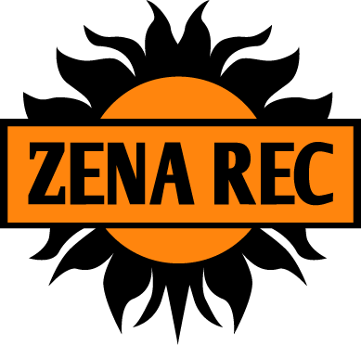
Private Swim, Tennis and Recreation Club Zena Recreation Park
PO Box 688
Woodstock NY 12498

2021 Tennis Lesson Registration Form

Family Name:

Parent / Guardian Name:

Phone #: Cell Phone #:

E-Mail:

Emergency Contact: Phone #:

Child’s Name | # weeks for  Non-members | Age | Level  (A-C) | Cost
*sales tax included

Total:

LEVELS: Level A = ages 5-9: Level B = ages 9 -11: Level C = ages 11 & up.
The Tennis Instructor may change a child’s level based on ability.

Session Dates: June 28 –Aug 12. 3 Fifty-minute sessions. A 9AM. B 10Am. C. 11 AM
Fee: Members - $160 per child
Non-Members $275 per child * for seven weeks
Non-Members: 1 week- $85; 2 weeks- $150; 4 weeks- $250

Please make checks payable to Zena Recreation Park or make a payment online at ZenaRec.com. There will NOT be refunds for sessions paid for and not attended. * If your family decides to become a Zena member this season, the cost difference for 6 weeks of lessons ($115) will be credited towards your membership. If season is stopped, prorated funds refunded.

I, the parent/guardian of the above named, hereby give my approval for the participation in Zena Recreation Park’s Tennis Lessons. I also state that the above named has been examined by a physician and found to be in good health and fit for tennis lessons. In case of emergency, I hereby authorize another available physician to treat my child (children).

Signature of
Parent/Guardian Date

Amount Paid Check # Date

